Pedestrian gates - inside

To open
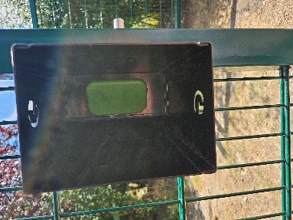
1. Reach into the black metal box.
Green plate
2. Push the right hand side of the green plate and pull it from the left.

3. Close the gate after leaving.

To close
1. Push gate firmly until it clicks

Gates should be closed at all times except on weekends when The Shop is open.

